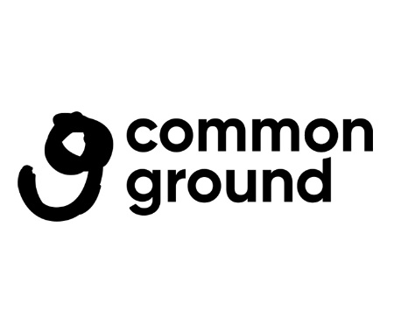
EQUALITY, DIVERSITY & INCLUSION POLICY
Introduction
Common Ground is an arts development organisation working since 1999 with artists and communities. Our rich and imaginative programmes build ways to address local and global issues through the unifying and transformative power of the arts. Common Ground anchors art in a community setting and has formed a unique practice and approach between the arts and community development. We work to ensure that everyone has access to the arts and is not dependent on where you are born, your education, wealth or identity.

Our mission is to act and advocate for equal access to and participation in arts and culture in our communities.
Our vision is of a society that values the vital role that arts and culture has in imagining, transforming, enriching and reflecting life in Ireland.
Our values are that we believe in:
The right of everyone to access and participate in arts and culture
The fundamental role of the artist
The transformative power of the arts

As an organisation Common Ground is committed to our legal obligations under the Equality Acts (1998-2015), the Equal Status Acts (2000-2018), and Section 42 of the Irish Human Rights and Equality Act 2014 (Public Sector Equality and Human Rights Duty). We are an Equal Opportunities employer and recognise that in our society, certain groups and individuals are discriminated against and denied equality of opportunity. We aim to create an environment in which equal opportunity is promoted to allow the development of the full potential of each person involved in our organisation and to ensure that no person is treated less favourably than another on the grounds of gender, civil status, family status, sexual orientation, age, disability, race, religion or membership of the Traveller Community. As part of our EDI policy we acknowledge the ongoing discussions to recognise socio-economic status as the tenth ground of discrimination in Irish equality legislation. In anticipation of this development, we continue to commit to proactively addressing socio-economic inequalities in our policies and practices.
What do we stand for?
Common Ground are committed to a fairer, more diverse Irish arts and cultural sector with wider roots across Irish Society. Our belief in the right of every person to access and participate in arts and culture underpins our Equality, Diversity and Inclusion policy. Our programmes of work support inclusive practices with integration and social justice at the heart of it.
We strive to be an organisation that is flexible, that listens and responds to the changing needs of our communities. We will continue to work collaboratively with community-based organisations in Dublin 8 to identify and address barriers to participation in the arts, ensuring our programmes are accessible and inclusive.
Dublin 8, where we are based, is an area undergoing continuous redevelopment bringing with it challenges for generations of local people who feel displaced by slow social housing regeneration processes, the impact of gentrification along with the opportunities for exploring integration with a more demographically and ethnically diverse community. Common Ground understands the value of the arts and creative activities in building people’s participation and community connectedness.

Common Ground’s EDI Policy Development Process
This EDI policy is a ‘living document’ that will develop and grow as Common Ground’s learning and commitment to Equality, Diversity and Inclusion continues to be embedded across our organisational structure and programmes of work.
We have developed Common Ground’s Equality, Diversity and Inclusion policy after a period of training for staff, including our executive teams’ participation in anti-racism training facilitated by Dr. Ebun Joseph, the Government Rapporteur on Racism, and initiated by Canal Communities Local Drug and Alcohol Task Force in 2024/2025. This training deepens our understanding of systemic racism and informs the development of key actions to foster a more inclusive environment within our organisation and the communities we serve.
In addition, the Director completed an Equality Studies Cert at Maynooth University in 2023. We also brought together staff and board for a consultation facilitated by Community Action Network, where we explored what Common Ground is presently doing to promote equality, diversity and inclusion and what practice changes need to happen to uphold our values of equality, diversity and inclusion across every strand of our work.
The external research paper ‘Common Ground: building spaces for artist practice and community engagement’ in 2024 also informs this policy. Through conversations with artists, community members and staff, board and advisors of Common Ground, this research paper looks at the artist workspaces we manage and informs how we can progress our work in these spaces and future opportunities for workspaces in the community. Our EDI policy is also informed by the Arts Council's Equality, Diversity and Inclusion toolkit, that offers practical examples and strategies to promote equality of participation, opportunity, access, and outcomes for all.

How we will implement and monitor this policy
We will align our EDI objectives with our 6th Strategic Plan (2026–2030), setting clear milestones to monitor our progress in promoting equality, diversity, and inclusion across all organisational and artistic programme areas and their implementation.
We will:
- Collect and analyse data on participation and engagement via artist selection and community engagement to identify gaps and inform targeted strategies that promotes inclusivity.

- Monitor, encourage and take action to ensure diversity is part of succession planning for our Board of Directors and executive staff team.

- Provide ongoing EDI training for staff, board members, and collaborators to foster a culture of continuous learning and improvement

- Review our EDI policy annually with board and staff incorporating feedback from stakeholders to ensure its relevance and effectiveness

